# Literature Review

## Battery

Many daily activities and appliances rely heavily on electrical energy and the storage of electrical energy. Although electrical elements such as capacitors are capable of storing electrical energy it is usually of very small magnitude, and hence there was need for other technology capable of storing more electrical energy. One of the oldest inventions for the storage of electrical energy was the battery. The electrochemical cell or battery contained chemicals that, when needed, would undergo go a chemical reaction with desired electrical energy as the product [1]. There are two main types of electrochemical cells, those that convert chemical energy into electrical energy (galvanic cells) and cells that convert electrical energy back to chemical energy (electrolytic cells) [2]. Combining these types of electrochemical cells, it is possible to produces batteries that discharge only or discharge and recharge. Electrochemical cells can either be considered as wet or dry depending on the state of the electrolyte [3]. The structure of a typical electrochemical cell is shown in Figure 1. Electrochemical processes have been studied for over 200 years varying the electrodes and electrolyte as technology improved to build better energy storage systems [4].

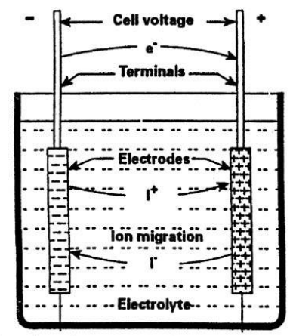

Figure 1: Structure of electrochemical cell

As mentioned previously batteries can be used as a purely discharge system or as a discharge recharge system, with the former most commonly used in small electrical devices (clocks, remotes, and toys) and the latter used for larger applications (cars, trains, planes, and renewable energy systems). Prior to the 1990s the main types of batteries for storage applications consisted of the Lead-acid battery and the Nickel Cadmium (NiCd) battery. However, today’s storage market is predominately made up of Lithium-ion (Li-ion) batteries, with double the storage density of its predecessors [5]. Efficiencies of Lead-acid batteries typically range between 70 – 90 % and lifetimes between 5 – 15 years, Li-ion batteries, however, exhibit higher efficiencies approximately 85 – 98 %, and lifetimes similar to that of Lead-acid batteries [6]. Table 1 lists the advantages and disadvantages of Lead-acid and Li-ion batteries.

Table 1: Advantages and disadvantages of Lead-Acid and Li-ion batteries

|  |  |  |
| --- | --- | --- |
|  | Advantages | Disadvantages |
| Lead-acid | * Reliable * Tolerant to overcharge * cheap | * Lead is toxic * Heavy metal * Limited life cycle * No fast-charge [7] |
| Li-ion | * Higher energy density and therefore occupy less space. * Ideal for frequency regulation * Cleaner and safer disposal | * Due to high energy density cells are prone to combustion * Sensitive to external heat, overcharging and high currents |

## Pumped Hydro

Another form of storing electrical energy is known as pumped hydroelectric storage (PHES). Unlike battery storage, which makes use of chemicals in the storage of electrical energy, PHES uses water reservoirs for the storage of energy. When implementing renewable energy systems such as PV or wind, the biggest impediment is that the majority of energy produced is during times of low demand, and hence PHES allows the storage of excess energy during off peak times and the release of this energy during peak times [8].

Systems that relied on water reservoirs as means of storage have been dated back to 1890 in Italy and Switzerland, however the PHES gained its popularity in the 1960s to 1980s [9]. The basic operation of a PHES system is illustrated in Figure 2. This type of storage system involves raising water from a lower reservoir to a higher reservoir during times when energy production is at an excess. The water is then released through a turbine during peak demand to compensate lower energy productions by the primary system [10]. At first though PHES energy systems seem to be 100 % energy efficient however due to water loss through evaporation due to open reservoirs the efficiency is approximately 70 – 80 % [11].

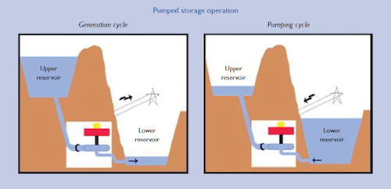

Figure 2: Basic operation of a pumped hydroelectric storage system

Although PHES systems account for the bulk of global energy storage systems, no large scale PHES systems have implemented in Australia in the last 30 years [12]. Table 2 outlines some advantages and disadvantages of PHES systems.

Table 2: Advantages and disadvantages of PHES systems

|  |  |
| --- | --- |
| Advantages | Disadvantages |
| * Does not require harmful chemicals * System can be constructed from natural elevations in the area * Largest capacity of energy storage * Flattens load variations | * Involves mechanical parts, hence maintenance may be more frequent * Becomes expensive to implement if landscape has no natural elevations. * Low energy density, hence large volumes of water required * Water evaporations due to open reservoirs * Negative environmental impacts |

The cost of PHES systems can vary greatly depending on the size of the system and the suitability of the location of implementation. World averages suggest that the cost unit of storage is between US$500/kWh and US$1500/kWh [13], with variation evolving mainly from the location of the system.

[1] D. Berndt, "Electrochemical Energy Storage," in *Battery Technology Handbook*, ed: CRC Press, 2003.

[2] B. Scrosati, K. M. Abraham, W. A. v. Schalkwijk, and J. Hassoun, *Lithium Batteries*. Somerset, UNITED STATES: John Wiley & Sons, Incorporated, 2013.

[3] R. E. White, *Electrochemical cell design*. New York: Plenum Press, 1984.

[4] C. R. Russell, *Elements of Energy Conversion*. Saint Louis, UNITED STATES: Elsevier Science, 2013.

[5] Y. Brunet, *Energy Storage*. Somerset, UNITED STATES: John Wiley & Sons, Incorporated, 2013.

[6] D. O. Akinyele and R. K. Rayudu, "Review of energy storage technologies for sustainable power networks," *Sustainable Energy Technologies and Assessments,* vol. 8, pp. 74-91, 12// 2014.

[7] J. M. Grothoff, "Battery Storage for Renewables: Market Status and Technology Outlook," *IRENA,* 2015.

[8] T. E. Institute. (2015). *How Better Battery Storage Will Expedite Renewable Energy*. Available: <http://www.ecowatch.com/how-better-battery-storage-will-expedite-renewable-energy-1882097909.html>

[9] D. Namgyel, *Wind Following with Pumped Hydroelectric Energy Storage in New Brunswick*: University of New Brunswick, Department of Electrical and Computer Engineering, 2012.

[10] F. S. Barnes and J. G. Levine, *Large Energy Storage Systems Handbook*. Boca Raton, UNITED STATES: CRC Press, 2011.

[11] L. L. C. Red Mountain Insights, *Utility Energy Storage : Profiles Batteries, Compressed Air Storage, Flywheels, Hydrogen, Superconducting Magnetic Energy Storage, Thermal Energy Storage, Ultracapacitors, and Vehicle-to-grid*. [Red Mountain, California?]: Red Mountain Insights LLC, 2012.

[12] P. Wellington, "Pumped hydroelectricity energy storage: Opportunities for Australia," *Energy News,* vol. 32, pp. 16-18, 2014.

[13] P. Lang. (2012, 28 / 03). *Pumped-hydro energy storage – cost estimates for a feasible system*. Available: <https://bravenewclimate.com/2010/04/05/pumped-hydro-system-cost/>